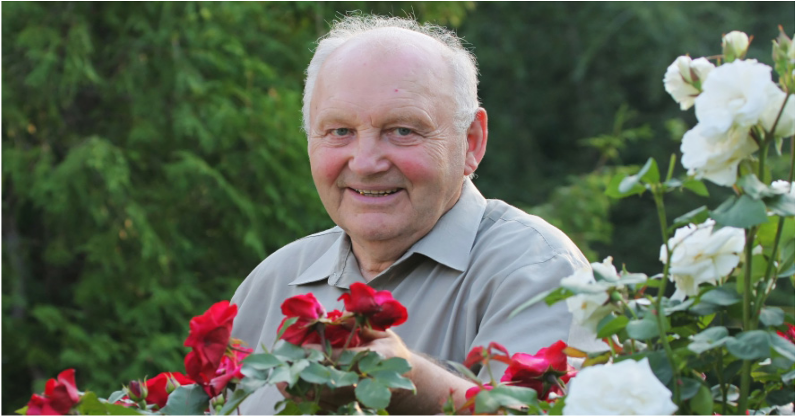

Higgins Bequest Trust

Application Package 2019

Donations to support the spiritual, pastoral, emotional, and social needs of elderly people in Hawkes Bay

he Higgins Bequest Trust was established with a gift in the will of the late Mr Shaun Vincent Higgins, to support the needs and wellbeing of elderly residents of Hawkes Bay. The Trust is administered by
a Board of Trustees under the provisions of the Charitable Trusts Act 1957.
T

Charitable purposes and objectives of the fund include:

1 The provision of funds for the spiritual, pastoral, emotional and social needs of elderly persons in the Hawkes Bay area

2 The provision of funds for the development, maintenance and implementation of services for the health care of the elderly in Hawkes Bay where services are either unmet or at risk of not being able to be sustained. Such services include but are not limited to
• community services • hospital care • rehabilitation • psychogeriatric services • pastoral care
3 The provision of funds for other areas associated with charitable care or support of all elderly persons in the Hawkes Bay area including • grants or remuneration for people working with elderly people • recreation, events and social amenities for elderly people • maintenance or provision of equipment to assist mobility and function of elderly • any other such related needs

4 At the discretion of the Board of the Higgins Bequest
Trust.

Particular emphasis will be given to the provision of personal and compassionate care. All services carried
out, including provision of care, are to reflect the application of Catholic principles and in particular the vow of hospitality.

Funds Available:

Closing Date for Applications:

Further Information:
Grants are made out of the interest accrued on the Trust’s capital account in any given year. Depending on the merit of applications received, the Board, at its discretion, may decide to award multiple small grants or one-two large grants. Funds available in any year are unlikely to exceed NZ$35,000.

All applications to the Trust are to be fully completed and received by the Trust no later than 28th February of each year. Applicants will be advised of the outcome of their application in mid April.
All applications and enquiries should be directed to: The Higgins Bequest Trust,
C/- P.O. Box 7024,
Sydenham,
Christchurch 8240
Email: higginsbequest.nz@nazarethcare.com

Higgins Bequest Trust Donation Application Form

Important:

1 Every section of this form must be completed in full. Additional information may be included to support this application.

2 Before completing this application form, please ensure that you and/or your organisation meets the criteria listed earlier in this application pack.

3 Closing Date: 28th February 2019.

Registered or full name of the organisation or individual applicant applying:

Postal address:

Organisation’s / applicant’s bank account: Account name:

Name and position of contact person: Telephone number:
Email address:

Registered or full name of umbrella or parent organisation, if applicable:

Type of organisation, if applicable, e.g. Charitable Trust, Incorporated Society:

Is the organisation GST registered and if so, what is the GST number:

Higgins Bequest Trust Donation Application Form

For Organisations:

President / Chairperson:

Telephone: Email:

Secretary: Telephone: Email:

Treasurer: Telephone: Email:

Aims and objectives of the organisation:

For All:

Please provide details of the project / reason for requesting a donation from the Higgins Bequest Trust. You may attach supplementary information if necessary.

Area or district or the project:

Number of people who will benefit:

Amount requested:

* Please note that at least two quotes received within the past 60 days must accompany any requests for capital items.

Please list other funding sources approached and supply details of donations and grants:

Higgins Bequest Trust Donation Guidelines

1 Applicant charities must be registered with the charities commission and administered by a properly incorporated body with an appointed committee or board and an auditor.
2 Each application is judged on its merits and will take account of the number of persons served.
3 Applications from organisations must be accompanied by a recent set of audited accounts or a reason why this is not possible.
4 Donations must be used by the organisation to assist them in achieving the aims and objectives for which they were set up. Donations must be used by the organisation or individual applicant for the project for which this application is
made.
5 Organisations/applicants are discouraged from becoming dependent on donations from the Higgins Bequest Trust.

Conditions of Application

1 The Higgins Bequest Trust reserves the right to publish the names of beneficiaries and details of any successful donation
2 The Higgins Bequest Trust reserves the right to request a report from the successful applicant/organisation on the
outcomes achieved as a result of receiving the donation.

Checklist - Items to be Included with this Application

Fully completed application form

Most recent set of audited accounts
Annual Report (if applicable)
Copy of Certificate of Incorporation (if applicable)
Copy of Charities Commission registration (if applicable) Bank deposit slip

In submitting this application, I/we agree to abide by the requirements of the Higgins Bequest Trust, declare this application represents full and accurate disclosure, and authorise the Trust and/or its agents to make any enquiries or undertake audits of myself/our organisation. Decisions made by the Higgins Bequest Trust are at the discretion of the Board and no correspondence or further discussions following a donation decision will be entered into.

I/we solemnly declare that the details contained in this application are true and correct to the best of our knowledge and we have the authority to commit to the above conditions.

Signature:

Signature:

Designation:

Designation:
(if applicable) (if applicable)

Date:

Date:

