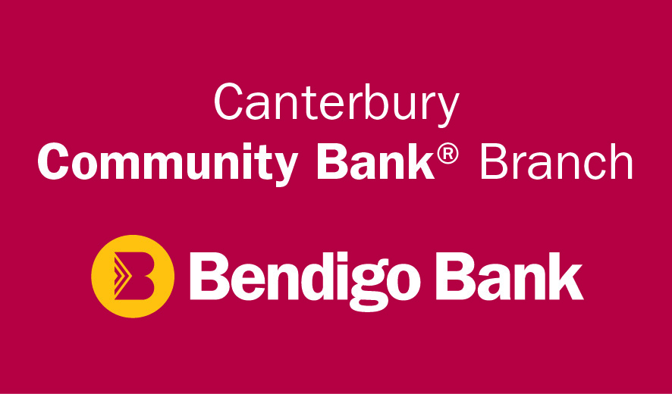
Nazareth House Camberwell gratefully acknowledges receipt of Bendigo Bank Canterbury Surrey Hills Community branch’s generous support and sponsorship of $10,000. This contribution will enable the creation of three entertainment hubs at Nazareth House that will increase connectivity of our residents with the wider community.
This is especially beneficial for the frailer residents of our community who are sometime unable or reluctant to venture outside the House for community interaction. Rather, we will now be able to bring the world indoors to them!
From our Exploring Our World activities, Movie Time or Music Time; even virtually connecting with distant families, these hubs will enhance our residents’ living experiences.
Please support Bendigo Bank in your everyday communities, as it supports ours, the Nazareth community.

